

UNITEDWORLD SCHOOL OF COMPUTATIONAL INTELLIGENCE (USCI)

Summative Assessment (SA)

Submitted BY

Patel Vanshkumar Jayantibhai

(Enrl. No.: 20220701018)

**Course Code and Title: 21BSCS23C02 – R Programming**

B.Sc. (Hons.) Computer Science / Data Science / AIML

III Semester – July – Nov 2023



Nov/Dec 2023

|  |  |  |
| --- | --- | --- |
| Sr.no. | Title | Page no. |
| 1 | Introduction   * Aim of the Project * Intended outcome | 3 |
| 2 | Dataset | 4 |
| 3 | Dataset Description | 7 |
| 4 | Statistical Analysis | 8 |
| 5 | Data Visualization | 14 |
| 6 | Conclusion | 18 |

Introduction

* Alcohol consumption is a multifaceted aspect of societal behavior, influenced by cultural, economic, and policy factors.
* This project delves into a comprehensive analysis of global alcohol consumption trends, focusing on data from specific countries such as Australia and Austria.

Aim of the Project:

The project aims to analyze trends in alcohol consumption, focusing on specific locations and regions. It seeks to identify patterns over time, explore regional variations, and assess the impact of policies or awareness campaigns. The goal is to provide insights into the dynamics of alcohol consumption, contributing valuable information for discussions on public health, policy formulation, and targeted interventions.

Intended Outcome:

1. **Understanding Patterns:** Gain insights into trends and patterns of alcohol consumption over time.
2. **Influence Factors:** Identify and examine factors influencing alcohol consumption patterns, such as demographic or socio-economic variables.
3. **Policy Impact:** Assess the impact of alcohol-related policies and interventions on consumption trends.
4. **Actionable Insights:** Provide actionable insights for policymakers, public health officials, and researchers.
5. **Informed Decision-Making:** Enhance understanding for informed decision-making in public health and policy formulation.
6. **Improved Public Health:** Ultimately, aim to contribute to improved public health outcomes related to alcohol consumption

Dataset

|  |  |  |  |  |  |
| --- | --- | --- | --- | --- | --- |
| index | LOCATION | INDICATOR | SUBJECT | TIME | LITRES/CAPITA |
| 0 | AUS | ALCOHOL | TOT | 1960 | 9.3 |
| 1 | AUS | ALCOHOL | TOT | 1961 | 9.4 |
| 2 | AUS | ALCOHOL | TOT | 1962 | 9.5 |
| 3 | AUS | ALCOHOL | TOT | 1963 | 9.8 |
| 4 | AUS | ALCOHOL | TOT | 1964 | 10.1 |
| 5 | AUS | ALCOHOL | TOT | 1965 | 10 |
| 6 | AUS | ALCOHOL | TOT | 1966 | 10.3 |
| 7 | AUS | ALCOHOL | TOT | 1967 | 10.8 |
| 8 | AUS | ALCOHOL | TOT | 1968 | 11.1 |
| 9 | AUS | ALCOHOL | TOT | 1969 | 11.6 |
| 10 | AUS | ALCOHOL | TOT | 1970 | 11.6 |
| 11 | AUS | ALCOHOL | TOT | 1971 | 11.6 |
| 12 | AUS | ALCOHOL | TOT | 1972 | 12.2 |
| 13 | AUS | ALCOHOL | TOT | 1973 | 12.9 |
| 14 | AUS | ALCOHOL | TOT | 1974 | 13.1 |
| 15 | AUS | ALCOHOL | TOT | 1975 | 12.9 |
| 16 | AUS | ALCOHOL | TOT | 1976 | 13.1 |
| 17 | AUS | ALCOHOL | TOT | 1977 | 13 |
| 18 | AUS | ALCOHOL | TOT | 1978 | 12.7 |
| 19 | AUS | ALCOHOL | TOT | 1979 | 12.7 |
| 20 | AUS | ALCOHOL | TOT | 1980 | 12.7 |
| 21 | AUS | ALCOHOL | TOT | 1981 | 12.8 |
| 22 | AUS | ALCOHOL | TOT | 1982 | 12.4 |
| 23 | AUS | ALCOHOL | TOT | 1983 | 12.2 |
| 24 | AUS | ALCOHOL | TOT | 1984 | 11.7 |
| 25 | AUS | ALCOHOL | TOT | 1985 | 11.8 |
| 26 | AUS | ALCOHOL | TOT | 1986 | 11.3 |
| 27 | AUS | ALCOHOL | TOT | 1987 | 11.4 |
| 28 | AUS | ALCOHOL | TOT | 1988 | 11.3 |
| 29 | AUS | ALCOHOL | TOT | 1989 | 11 |
| 30 | AUS | ALCOHOL | TOT | 1990 | 10.6 |
| 31 | AUS | ALCOHOL | TOT | 1991 | 10.1 |
| 32 | AUS | ALCOHOL | TOT | 1992 | 9.9 |
| 33 | AUS | ALCOHOL | TOT | 1993 | 10.2 |
| 34 | AUS | ALCOHOL | TOT | 1994 | 10 |
| 35 | AUS | ALCOHOL | TOT | 1995 | 9.8 |
| 36 | AUS | ALCOHOL | TOT | 1996 | 10 |
| 37 | AUS | ALCOHOL | TOT | 1997 | 10.2 |
| 38 | AUS | ALCOHOL | TOT | 1998 | 10 |
| 39 | AUS | ALCOHOL | TOT | 1999 | 10 |
| 40 | AUS | ALCOHOL | TOT | 2000 | 10.2 |
| 41 | AUS | ALCOHOL | TOT | 2001 | 10 |
| 42 | AUS | ALCOHOL | TOT | 2002 | 10.4 |
| 43 | AUS | ALCOHOL | TOT | 2003 | 10.3 |
| 44 | AUS | ALCOHOL | TOT | 2004 | 10.5 |
| 45 | AUS | ALCOHOL | TOT | 2005 | 10.5 |
| 46 | AUS | ALCOHOL | TOT | 2006 | 10.8 |
| 47 | AUS | ALCOHOL | TOT | 2007 | 10.8 |
| 48 | AUS | ALCOHOL | TOT | 2008 | 10.8 |
| 49 | AUS | ALCOHOL | TOT | 2009 | 10.7 |
| 50 | AUS | ALCOHOL | TOT | 2010 | 10.4 |
| 51 | AUS | ALCOHOL | TOT | 2011 | 10.2 |
| 52 | AUS | ALCOHOL | TOT | 2012 | 10 |
| 53 | AUS | ALCOHOL | TOT | 2013 | 9.9 |
| 54 | AUS | ALCOHOL | TOT | 2014 | 9.7 |
| 55 | AUS | ALCOHOL | TOT | 2015 | 9.8 |
| 56 | AUS | ALCOHOL | TOT | 2016 | 9.5 |
| 57 | AUS | ALCOHOL | TOT | 2017 | 9.5 |
| 58 | AUT | ALCOHOL | TOT | 1960 | 8.8 |
| 59 | AUT | ALCOHOL | TOT | 1961 | 9.4 |
| 60 | AUT | ALCOHOL | TOT | 1962 | 9.4 |
| 61 | AUT | ALCOHOL | TOT | 1963 | 10.1 |
| 62 | AUT | ALCOHOL | TOT | 1964 | 10.7 |
| 63 | AUT | ALCOHOL | TOT | 1965 | 11.2 |
| 64 | AUT | ALCOHOL | TOT | 1966 | 13 |
| 65 | AUT | ALCOHOL | TOT | 1967 | 12.7 |
| 66 | AUT | ALCOHOL | TOT | 1968 | 13.4 |
| 67 | AUT | ALCOHOL | TOT | 1969 | 13.2 |
| 68 | AUT | ALCOHOL | TOT | 1970 | 13.3 |
| 69 | AUT | ALCOHOL | TOT | 1971 | 13.9 |
| 70 | AUT | ALCOHOL | TOT | 1972 | 14.4 |
| 71 | AUT | ALCOHOL | TOT | 1973 | 14.6 |
| 72 | AUT | ALCOHOL | TOT | 1974 | 14.6 |
| 73 | AUT | ALCOHOL | TOT | 1975 | 14.1 |
| 74 | AUT | ALCOHOL | TOT | 1976 | 14.2 |
| 75 | AUT | ALCOHOL | TOT | 1977 | 14.3 |
| 76 | AUT | ALCOHOL | TOT | 1978 | 13.5 |
| 77 | AUT | ALCOHOL | TOT | 1979 | 13.6 |
| 78 | AUT | ALCOHOL | TOT | 1980 | 13.6 |
| 79 | AUT | ALCOHOL | TOT | 1981 | 13.4 |
| 80 | AUT | ALCOHOL | TOT | 1982 | 13.5 |
| 81 | AUT | ALCOHOL | TOT | 1983 | 14 |
| 82 | AUT | ALCOHOL | TOT | 1984 | 13.8 |
| 83 | AUT | ALCOHOL | TOT | 1985 | 13.3 |
| 84 | AUT | ALCOHOL | TOT | 1986 | 13.6 |
| 85 | AUT | ALCOHOL | TOT | 1987 | 13.6 |
| 86 | AUT | ALCOHOL | TOT | 1988 | 13.7 |
| 87 | AUT | ALCOHOL | TOT | 1989 | 13.9 |
| 88 | AUT | ALCOHOL | TOT | 1990 | 14 |
| 89 | AUT | ALCOHOL | TOT | 1991 | 14 |
| 90 | AUT | ALCOHOL | TOT | 1992 | 13.6 |
| 91 | AUT | ALCOHOL | TOT | 1993 | 13.5 |
| 92 | AUT | ALCOHOL | TOT | 1994 | 12.5 |
| 93 | AUT | ALCOHOL | TOT | 1995 | 13.4 |
| 94 | AUT | ALCOHOL | TOT | 1996 | 13.5 |
| 95 | AUT | ALCOHOL | TOT | 1997 | 12.9 |
| 96 | AUT | ALCOHOL | TOT | 1998 | 12.9 |
| 97 | AUT | ALCOHOL | TOT | 1999 | 12.8 |
| 98 | AUT | ALCOHOL | TOT | 2000 | 13.2 |

Dataset Description

Dataset Description:

The dataset captures alcohol consumption trends across locations, providing information on the type of data measured ("ALCOHOL"), subject category ("TOT" for total consumption), and Litres/Capita for each year. With details on geographic locations such as Australia and Austria, the dataset facilitates concise analysis of cross-country patterns and temporal trends in alcohol consumption. The metric "Litres/Capita" quantifies per capita alcohol consumption in liters, offering valuable insights for research on public health and policy strategies.

Columns in the Dataset

* Index
* LOCATION
* INDICATOR
* SUBJECT
* TIME
* LITRES/CAPITA

Statistical Analysis

* 1. Print the data set

Input:

data("Alcohole_Con")

print(Alcohol_Con)

Output:

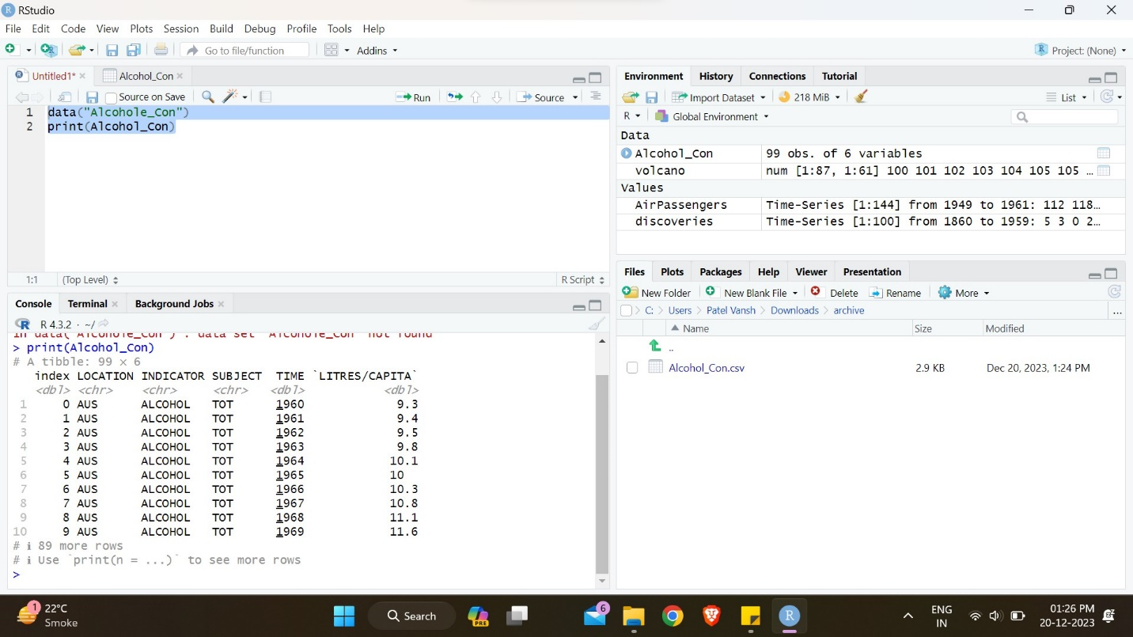

* 1. Calculates the maximum value within the column named LITRES/CAPITA

Input:

max(Alcohol_Con$`LITRES/CAPITA`)

Output:

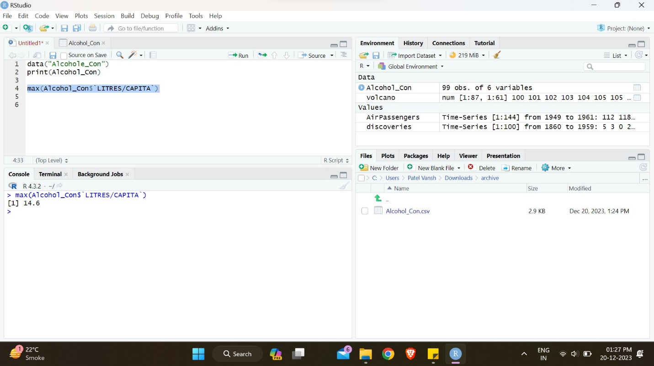

* 1. Calculates the minimum value within the column named LITRES/CAPITA

Input:

min(Alcohol_Con$`LITRES/CAPITA`)

Output:

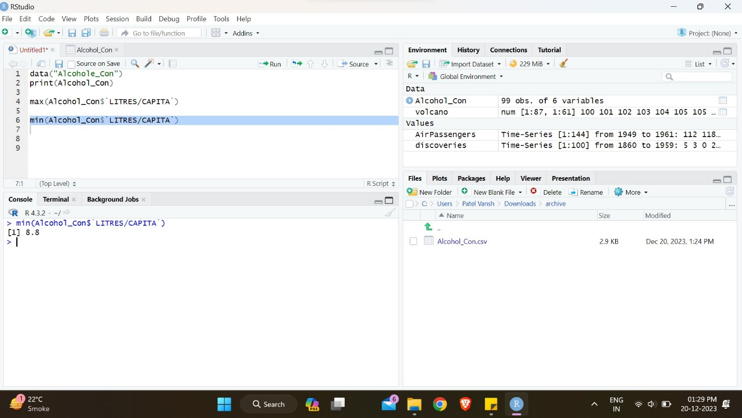

* 1. Calculates the mean value within the column named LITRES/CAPITA

Input:

mean(Alcohol_Con$`LITRES/CAPITA`)

Output:

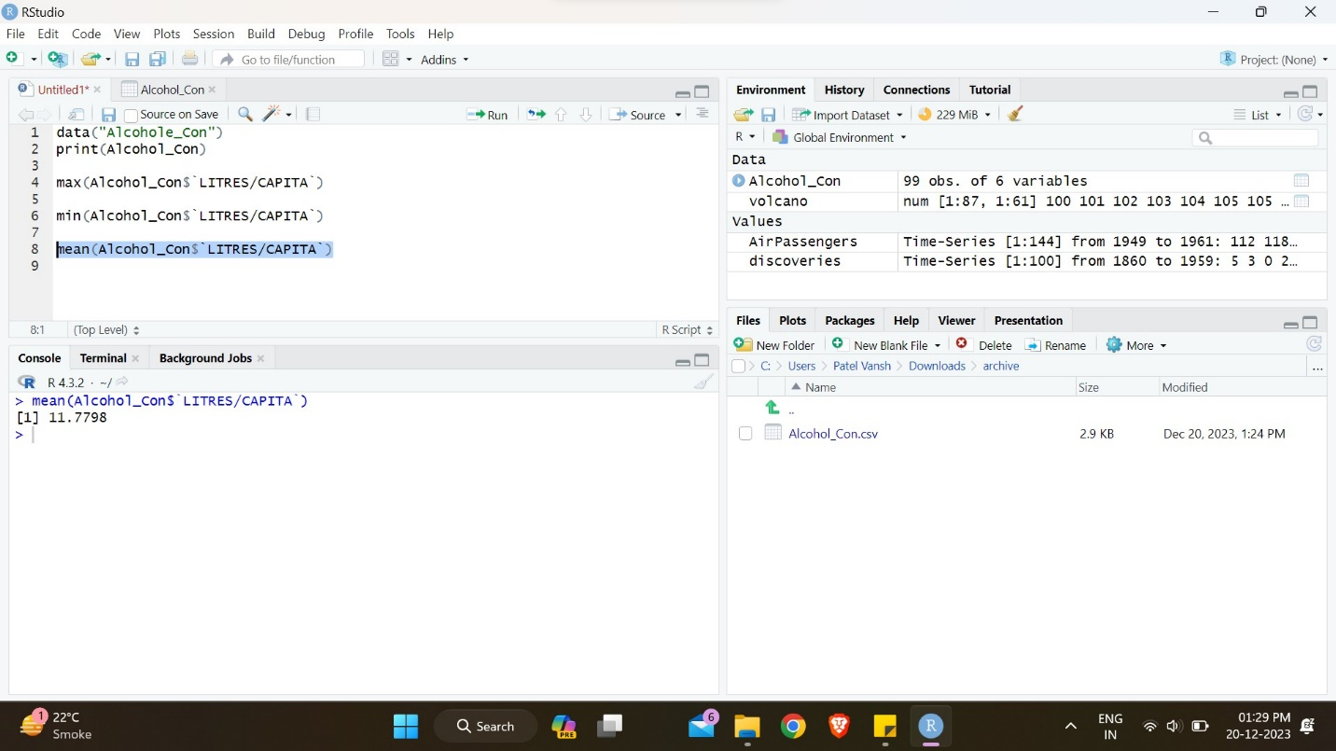

* 1. Calculates the median value within the column named LITRES/CAPITA

Input:

median(Alcohol_Con$`LITRES/CAPITA`)

Output:

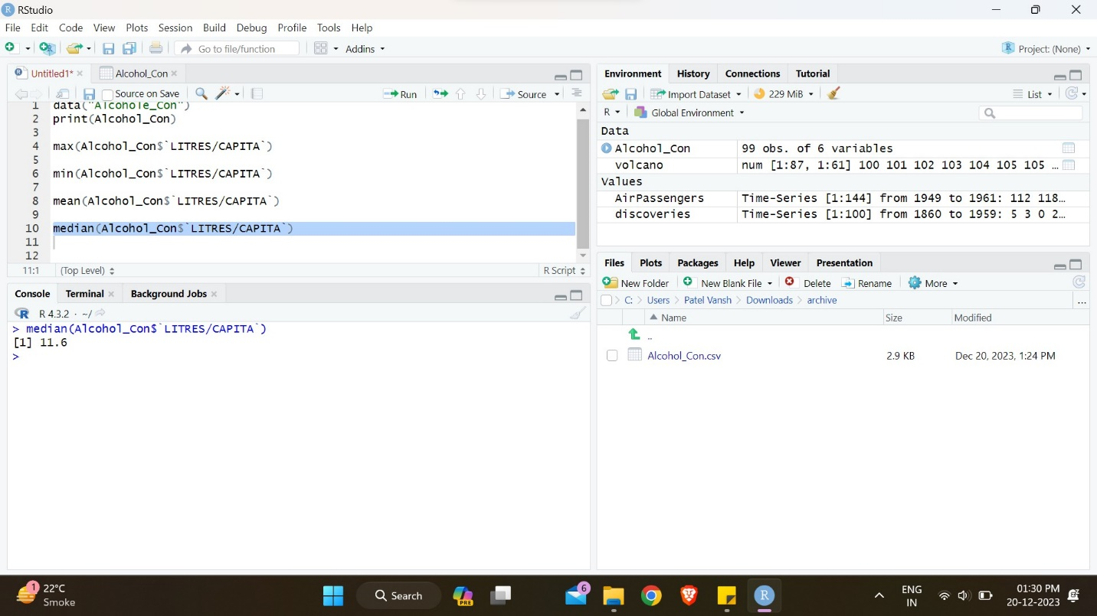

* 1. Calculates the Variance of the value within the column named LITRES/CAPITA

Input:

var(Alcohol_Con$`LITRES/CAPITA`)

Output:

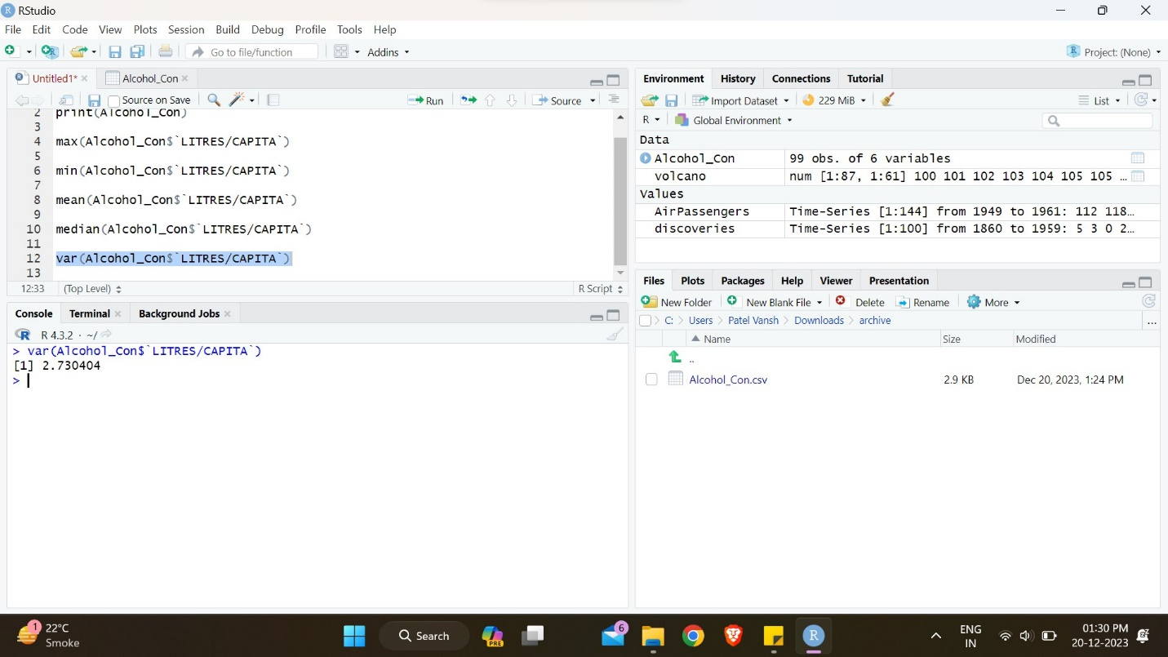

Data Visualization

1. creates a histogram for the values in the column labeled LITRES/CAPITA

Input:

hist(Alcohol_Con$`LITRES/CAPITA`)

Output:

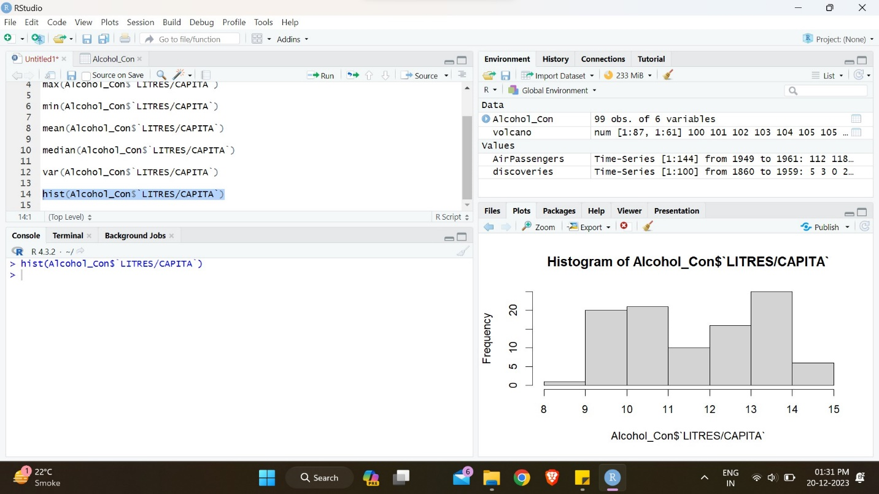

1. creates a histogram for the values in the column labeled LITRES/CAPITA and make column=green and border=black

Input:

hist(Alcohol_Con$`LITRES/CAPITA`,col="green",border="black")

Output:

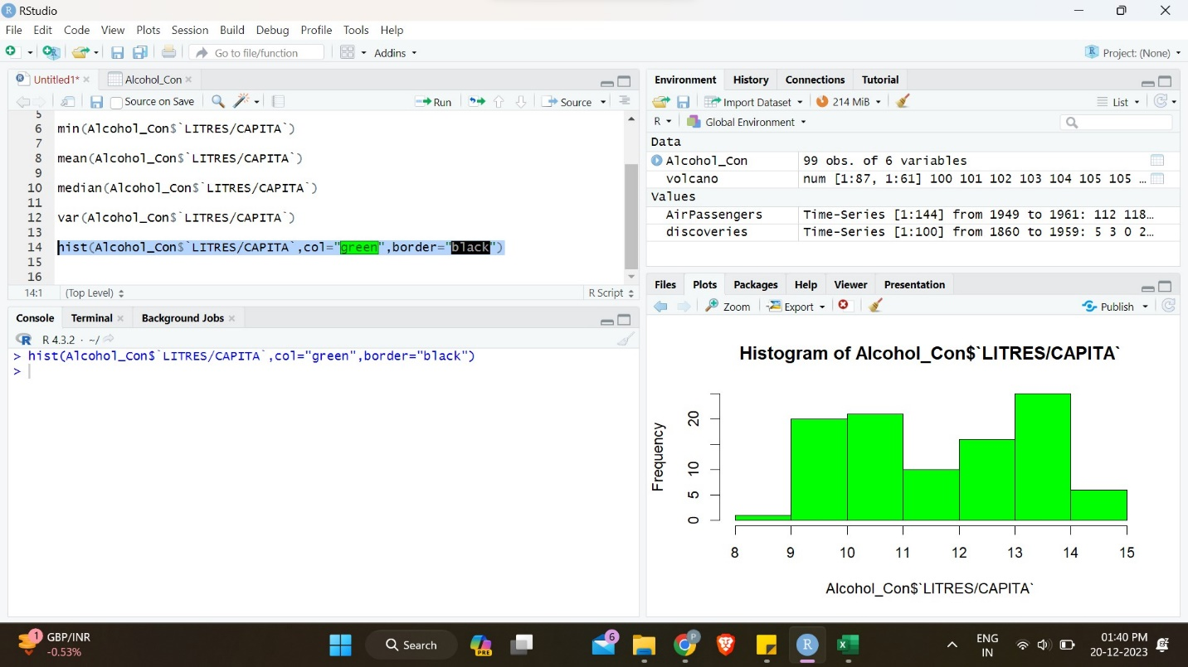

1. Create & Analysis the Bar plot of Total Alcohol Consumption in Australia Over Time

Input:

str(Alcohol_Con)

aus_alcohol_data <- subset(Alcohol_Con, LOCATION == "AUS" & INDICATOR == "ALCOHOL" & SUBJECT == "TOT")

print(aus_alcohol_data)

barplot(aus_alcohol_data$`LITRES/CAPITA`,

names.arg = aus_alcohol_data$TIME,

main = "Alcohol Consumption in Australia (Total)",

xlab = "Year",

ylab = "Litres per Capita",

col = "blue",

border = "black",

ylim = c(0, max(aus_alcohol_data$`LITRES/CAPITA`) + 1),

beside = TRUE) # Use 'beside = TRUE' for side-by-side bars

grid()

Output:

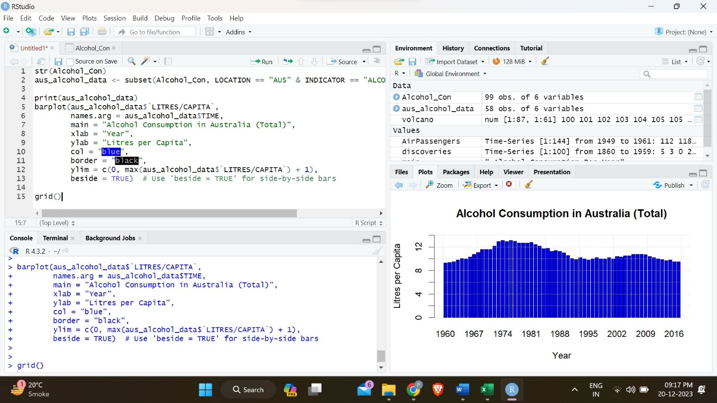

1. Pie Chart of Alcohol Consumption Distribution in Australia Over Time

Input:

aus_alcohol_data <- subset(Alcohol_Con, LOCATION == "AUS" & INDICATOR == "ALCOHOL" & SUBJECT == "TOT")

pie(aus_alcohol_data$`LITRES/CAPITA`,

labels = aus_alcohol_data$TIME,

main = "Alcohol Consumption in Australia (Total)",

col = rainbow(length(aus_alcohol_data$TIME)),

cex = 0.4)

Output:

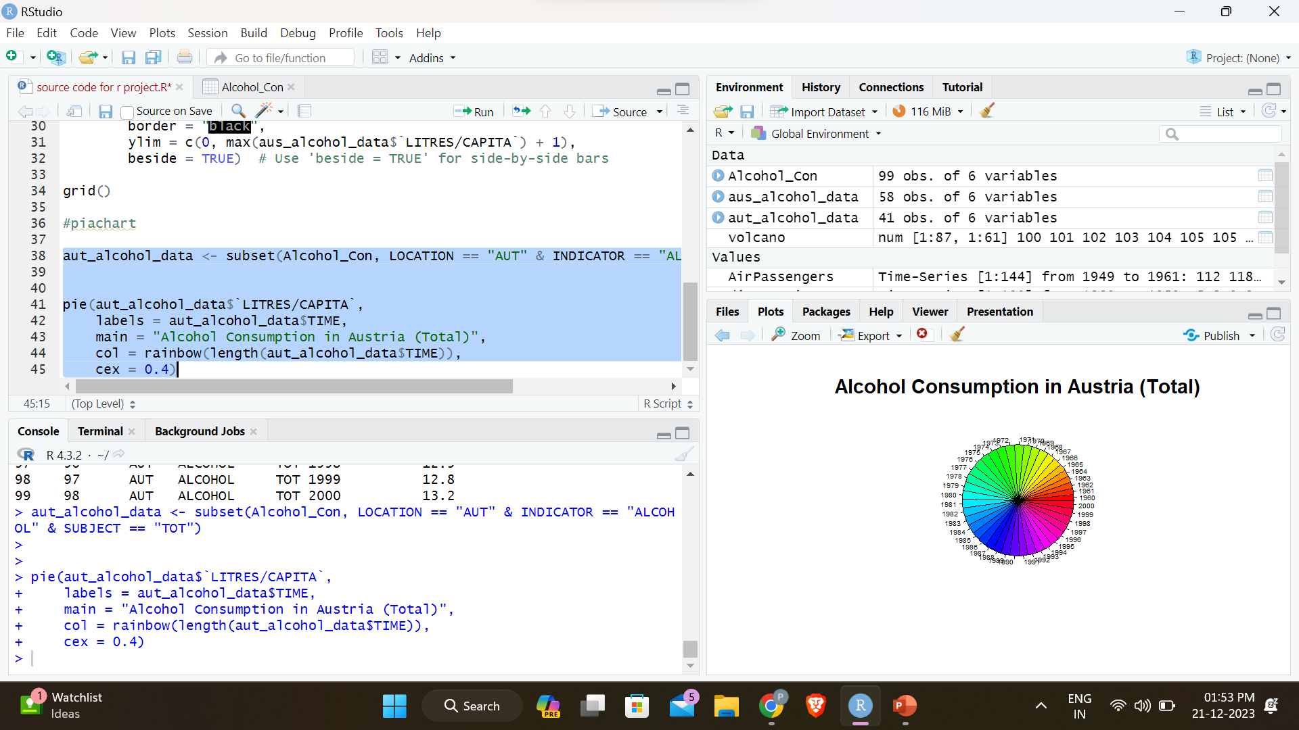

Conclusion

In conclusion, our exploration into global alcohol consumption trends has unveiled multifaceted insights into the dynamics that shape societal behaviors surrounding alcohol. The dataset, "GlobalAlcoholTrends," has proven to be a valuable resource in unraveling patterns over time, with a particular focus on Australia and Austria.

1. **Temporal Analysis:**
   * Explore trends over time to identify any patterns or significant changes in alcohol consumption.
   * Consider conducting time series analysis to understand the temporal dynamics better.
2. **Geographic Comparison:**
   * Extend comparisons to multiple countries or regions to identify global or regional trends.
   * Investigate countries with notable increases or decreases in consumption for potential case studies.
3. **Policy Impact Assessment:**
   * Examine the relationship between changes in alcohol-related policies and fluctuations in consumption.
   * Consider collaborating with policymakers to evaluate the effectiveness of existing policies.
4. **Demographic Correlations:**
   * Analyze how alcohol consumption correlates with demographic factors like age, gender, or socioeconomic status.
   * Identify groups that may be more susceptible to changes in consumption patterns.
5. **Outliers and Anomalies:**
   * Investigate outliers or anomalies in the data for potential research opportunities.
   * Examine the circumstances surrounding extreme values.
6. **Long-Term Forecasting:**
   * Utilize historical data to create models for forecasting future alcohol consumption trends.
   * Consider collaborating with data scientists or statisticians for advanced modeling.
7. **Qualitative Analysis:**
   * If possible, supplement quantitative analysis with qualitative research methods.
   * Conduct interviews or surveys to gather contextual information on drinking habits and cultural influences.
8. **Data Validation and Cleaning:**
   * Ensure the dataset is clean and accurate, addressing any missing or inconsistent data.
   * Validate data against external sources to enhance reliability.
9. **Collaboration and Communication:**

* Collaborate with experts in public health, sociology, or related fields for a multidisciplinary perspective.